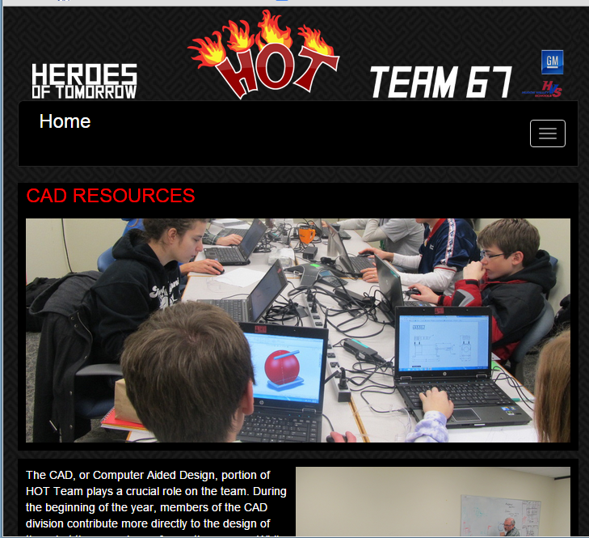

Page Content

<div id=”content”>

Page Banner

-Title <h1>

-Big Picture

<div id=”subbanner” >

Menu **Included in Dynamic Template**

Team Banner **Included in Dynamic Template**